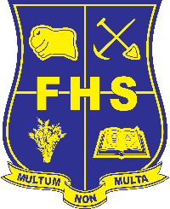

HSC Minimum Standards

Attention parent and caregivers
As has been widely advertised by the school and in the media, a minimum standard of literacy and numeracy will be required to receive the HSC in 2020. After a Government recall of the proposal to make all students from 2020 onwards sit online tests.
Students in Year 10 2018 will have the opportunity to demonstrate the HSC minimum standard by taking new short online tests in Years 10, 11 or 12.
Students who received a band 8 or above in each of the Naplan Year 9 reading, writing and numeracy tests will not have to take further tests.
Online tests will be available for students to sit at least twice a year in years 10, 11 and 12.
Students at Forbes High School who have not met the literacy or numeracy standard by achieving band 8 or above in Naplan 2017 will be sitting the first tests commencing on Monday 13th August and Tuesday 14th August 2018.
Students will be notified by letter of their allocated testing date and room. Results from the first testing date should be available before the next test period.
There will be another opportunity later in the year to reattempt the test or if absent for any reason.
Students may also go to the NESA website and attempt practice tests at the link below:
http://educationstandards.nsw.edu.au/wps/portal/nesa/11-12/hsc/hsc-minimum-standard/online-tests/what-to-expect-in-the-tests
Students will be notified of their testing date by letter and required to attend with their own device (set up to be able to access school networks) or ready to use the school laptops on both dates.
Further information can be found overleaf or inquiries can be directed to the school on 68522666.
Regards

David Lickess
Minimum Standards testing co-ordinator

